

**Project Assignment 3**

**Project's name: GALWAY 2020**

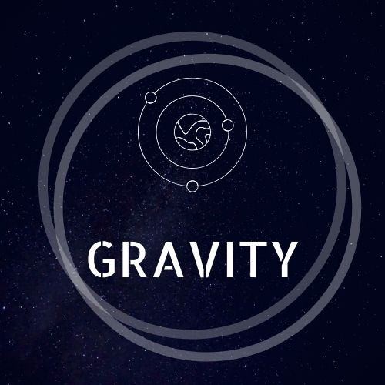

*Team GRAVITY*

Katarzyna Krakowska G00364903 – Scrum Master

Minh Tran G00365411 – Product Owner

Edgars Becs G00377012 - Programmer

Stephen Melly G00334648 - Tester

Thomas Burke G00362619 - Programmer

Submission date: 10th Feb 2020

Contents

1. Features / User Story identification and creation. 3

2. User Story sizing 4

3. User Story definitions of READY and DONE 6

4. Team Working Agreement 7

5. GitHub link 11

# Features / User Story identification and creation.

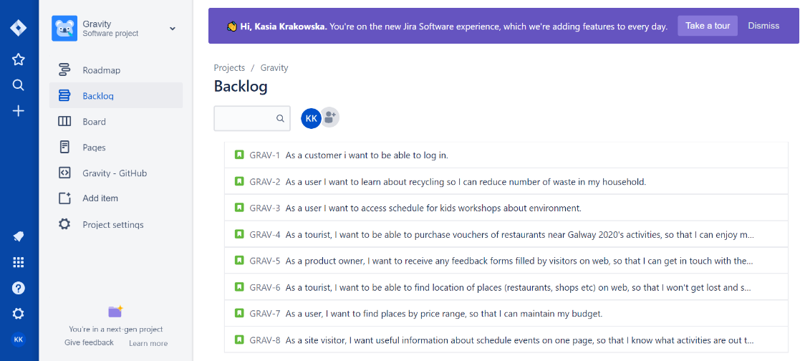

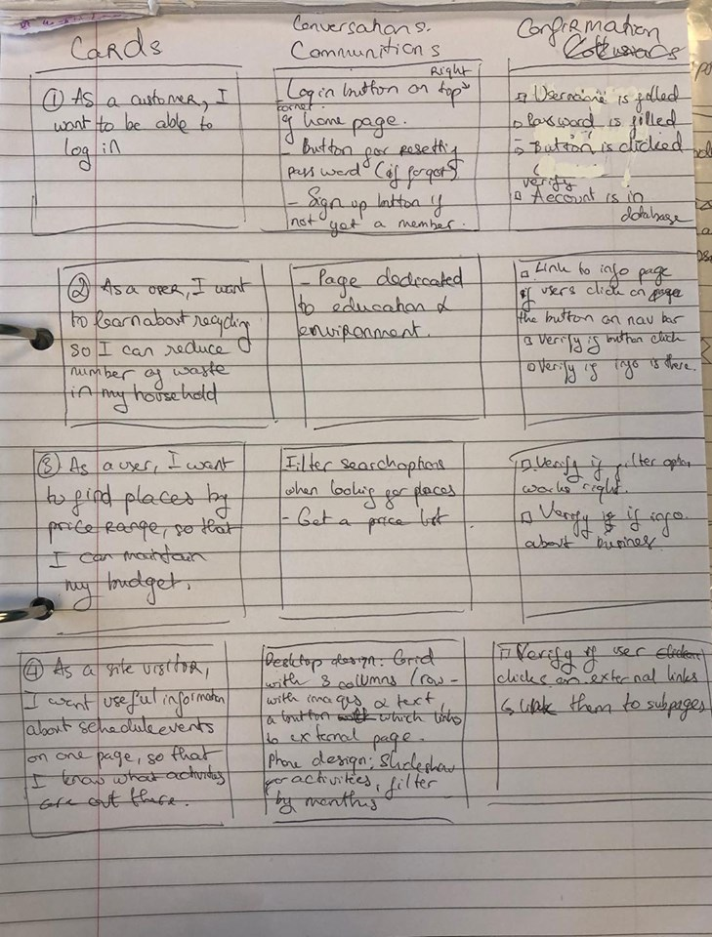

# User Story sizing

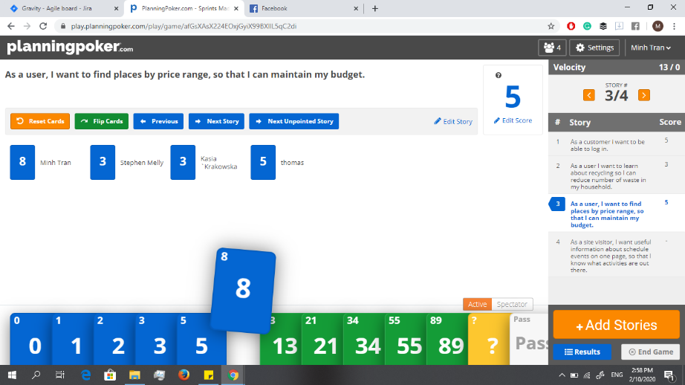

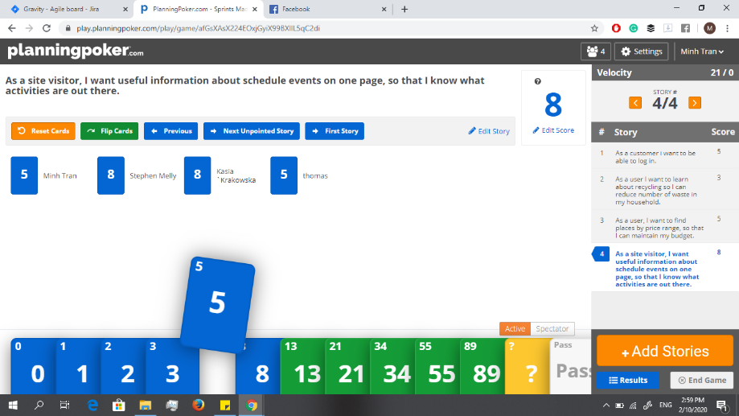

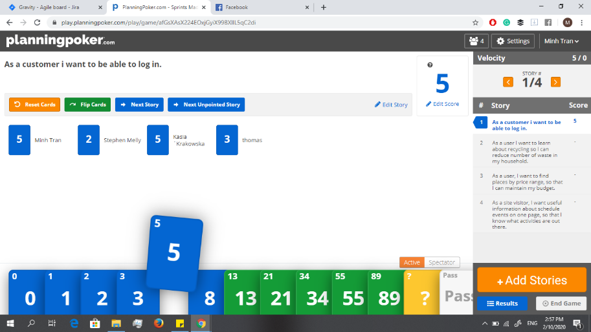

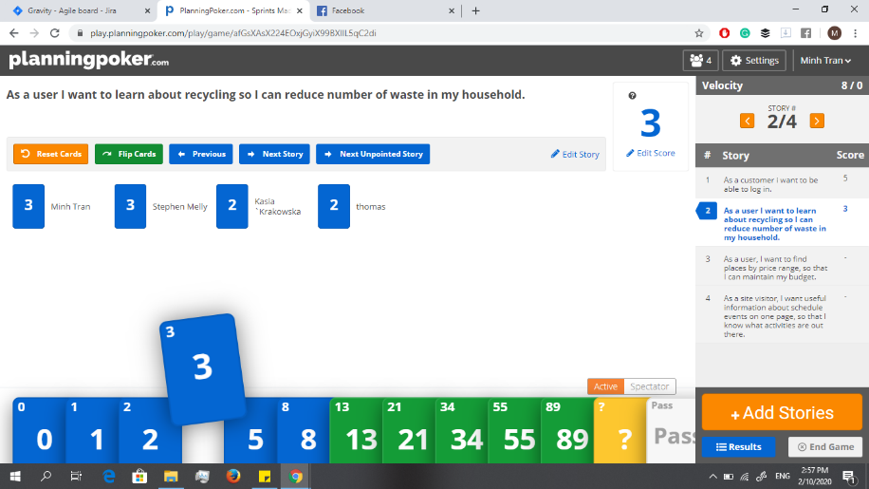

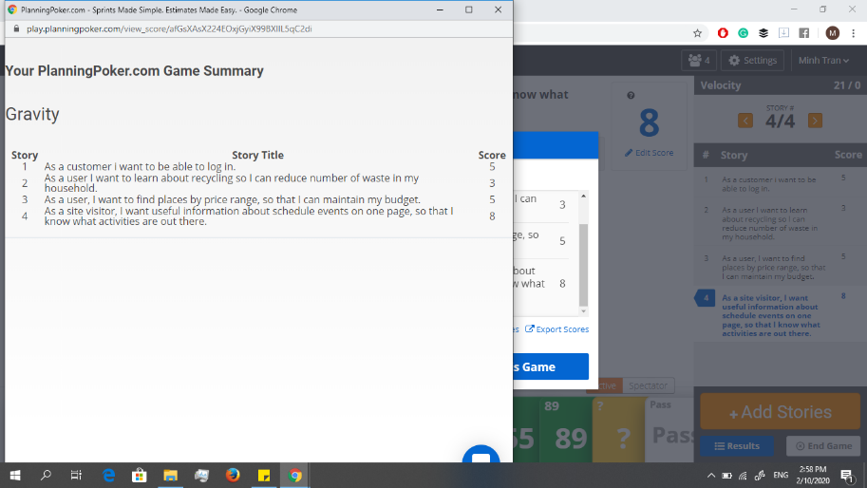

# User Story definitions of READY and DONE

***Definition of ready (before going into sprint):***

User stories must be completely described, sized and their test cases are already written.

Team must be able to specify what is each story's functionality, who benefits from it and its solution (what should we do to accomplish it).

***Definition of done:***

The story's solution is completely specified and integrated, with test cases included.

# Team Working Agreement

We chose to include six points in or Team Working Agreement after discussing essential element of teamwork.

***Team agreement.***

1. Active participation.
2. Take part in Stand-up meetings and brainstorming sessions.
3. Follow deadlines.
4. Show respect.
5. Show initiative - don't wait for others to do the work.
6. Follow the process (steps).

Teams argumentation for each point.

***Minh Tran***

1. Active participation.

For everyone needs to take the imitative throughout the project’s process, from contributing to the code, workloads or documentations to communicating with teams on agreed platform.

1. Take part in Stand-up meetings and brainstorming sessions.

As we will have stand-up meeting weekly to discuss and catch up with the state of process, everyone needs to join in and contribute to the meeting.

1. Follow deadlines.

We have specific works & documents need to be submitted weekly providing with the brief, so everyone in team must know what our submissions are every week.

1. Show respect.

Respect other works & time. If in the case there are different opinions, bring it on to the stand-up meeting to discuss in group. Actively take the lead in the project’s work.

1. Show initiative - don't wait for others to do the work.

Tell teammates which you would like to do in the weekly submissions, don’t wait for anyone to assign tasks.

1. Follow the process (steps).

Don’t jump ahead work, follow the process which will ensure workflow, clarity and deadlines.

***Thomas Burke***

1. Active participation.

Having everyone actively work on the project has the team work much better than 2 out of the 4-team working.

1. Take part in Stand-up meetings and brainstorming sessions.

Better brainstorming and meetings.

1. Follow deadlines.

Having each member of team meeting their deadlines help the rest of the team as they aren't waiting on them or getting backlogged.

1. Show respect.

Others in the group must be respected as they may be off differing skill or opinion.

1. Show initiative - don't wait for others to do the work.

Be ready to do tasks, don't wait on other's, express what you would like to do.

1. Follow the process (steps).

Don't jump ahead and go do things that aren't to be done yet as they may change later in what’s needed.

***Edgars Becs***

1. Active participation.

Actively express their views and issues at team meeting.

1. Take part in Stand-up meetings and brainstorming sessions.

Take part in every Team meeting, if can’t attend get minutes of meeting to stay up to date with team progress. Be on time for meetings. Brainstorm in meetings and take notes of ideas.

1. Follow deadlines

Follow deadlines to help team to complete Sprints in time and increase productivity.

1. Show respect.

All team participants view to be respected and considered when making decisions (tech, support, Scrum Master, PO).

1. Show initiative - don't wait for others to do the work.

Show initiative when delegating tasks but don’t intervene with someone’s tasks assigned.

***Stephen Melly***

1. Active participation.

The group cannot function to fit’s full extent if members do not participate. Doing so will ensure the project will get completed.

1. Take part in Stand-up meetings and brainstorming sessions.

Taking part in Stand up-meetings and brainstorming sessions allows the team to communicate ideas to each other and can also help clarify existing tasks or concepts.

1. Follow deadlines.

Deadlines are there for a reason if we miss a deadline suddenly, we are overdue with one submission with another just around the corner. Ensuring we have good time management and organisational skills will help us all as a team to achieve our deadlines.

1. Show respect.

Respecting everyone’s work is important, in cases you may not agree with someone else’s idea it is still important to show respect and mutually work to agree on a standard.

1. Show initiative - don't wait for others to do the work.

If there is a job to be done and the rest of the team is busy it’s that team members job to pick up what need to be done and execute any necessary, task.

***Katarzyna Krakowska***

1. Active participation.

Team members should put the group's goals above their own. One person may not be able to implement the project with the same effect as the team. Working in a group will be more effective if everyone works together. It will also allow us to complete tasks faster.

1. Take part in Stand-up meetings and brainstorming sessions.

The meetings aim to summarize the work done as well as to set the goals necessary to complete the next stage. We are all responsible for the result and the opinion of each of us is very important.

1. Follow deadlines.

Team members are responsible for completing the tasks assigned to them in time.

1. Show respect.

It is important to respect the opinions and ideas of others and try to work out a compromise. Attitude like being unable to communicate with others, being closed to the team’s ideas, believing that only his/her ideas are the best, are unhealthy, damaging and disruptive in teamwork.

1. Show initiative - don't wait for others to do the work.

While working in a group, we feel anonymous, so we can put less energy and commitment than if we worked alone. Teamwork allow us to exchange ideas, support each other, do everything for the whole team.

1. Follow the process (steps).

Project has specified steps that need to be completed one after another. Its important to follow those steps first to avoid missing deadlines.

# GitHub link

<https://github.com/thomasburke121/Gravity>